**Quickstart for building GitHub Apps**

**Quickly build a GitHub App that comments on pull requests.**

[**Step 1: Clone the app code**](https://docs.github.com/en/apps/creating-github-apps/writing-code-for-a-github-app/quickstart#step-1-clone-the-app-code)

**To help you get started quickly, we wrote code that you can use. If you want to learn how to write the code yourself, see "**[**Building a GitHub App that responds to webhook events**](https://docs.github.com/en/apps/creating-github-apps/guides/building-a-github-app-that-responds-to-webhook-events)**".**

1. **Clone the**[**github/github-app-js-sample**](https://github.com/github/github-app-js-sample)**repository. For more information, see "**[**Cloning a repository**](https://docs.github.com/en/repositories/creating-and-managing-repositories/cloning-a-repository)**." You may use a local clone or GitHub Codespaces.**
2. **In a terminal window, navigate to the directory where your clone is stored.**
3. **Run npm install to install the dependencies.**

[**Step 2: Get a webhook proxy URL**](https://docs.github.com/en/apps/creating-github-apps/writing-code-for-a-github-app/quickstart#step-2-get-a-webhook-proxy-url)

In order to develop your app locally, you can use a webhook proxy URL to forward webhooks from GitHub to your computer or codespace. This quickstart uses Smee.io to provide a webhook proxy URL and forward webhooks.

1. In your browser, navigate to <https://smee.io/>.
2. Click **Start a new channel**.
3. Copy the full URL under "Webhook Proxy URL". You will use this URL in a later step.

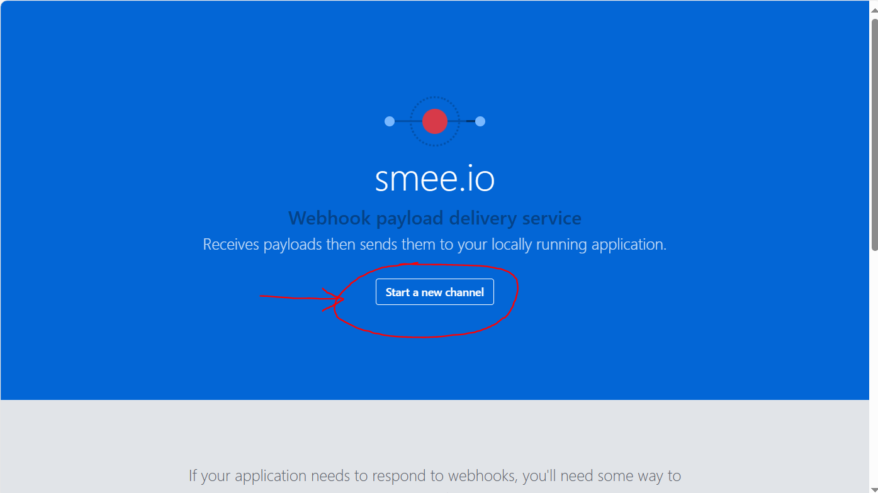

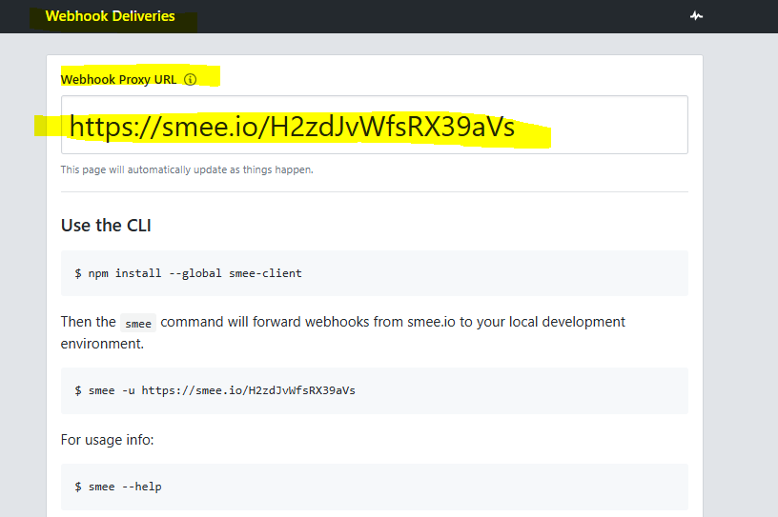

<https://smee.io/H2zdJvWfsRX39aVs>

[**Step 3: Register a GitHub App**](https://docs.github.com/en/apps/creating-github-apps/writing-code-for-a-github-app/quickstart#step-3-register-a-github-app)

The following steps will guide you through configuring the app settings that are required for this quickstart. For more information about the settings, see "[Registering a GitHub App](https://docs.github.com/en/apps/creating-github-apps/creating-github-apps/creating-a-github-app)."

1. In the upper-right corner of any page on GitHub, click your profile photo.
2. Navigate to your account settings.
   * For an app owned by a personal account, click **Settings**.
   * For an app owned by an organization:
     1. Click **Your organizations**.  
        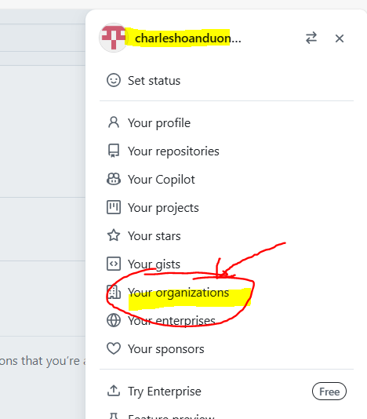
     2. To the right of the organization, click **Settings**.  
        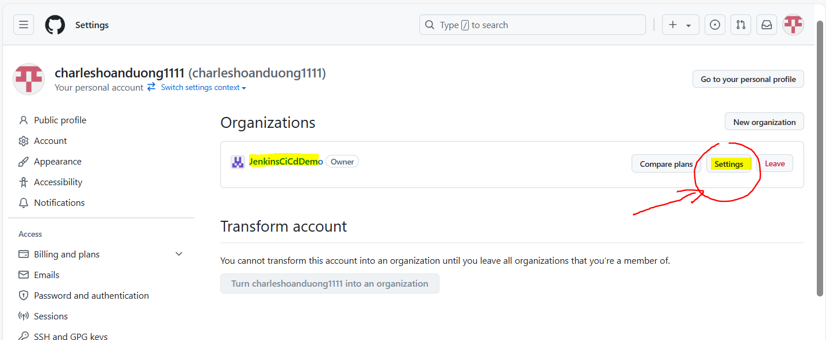
3. In the left sidebar, click **Developer settings**.  
   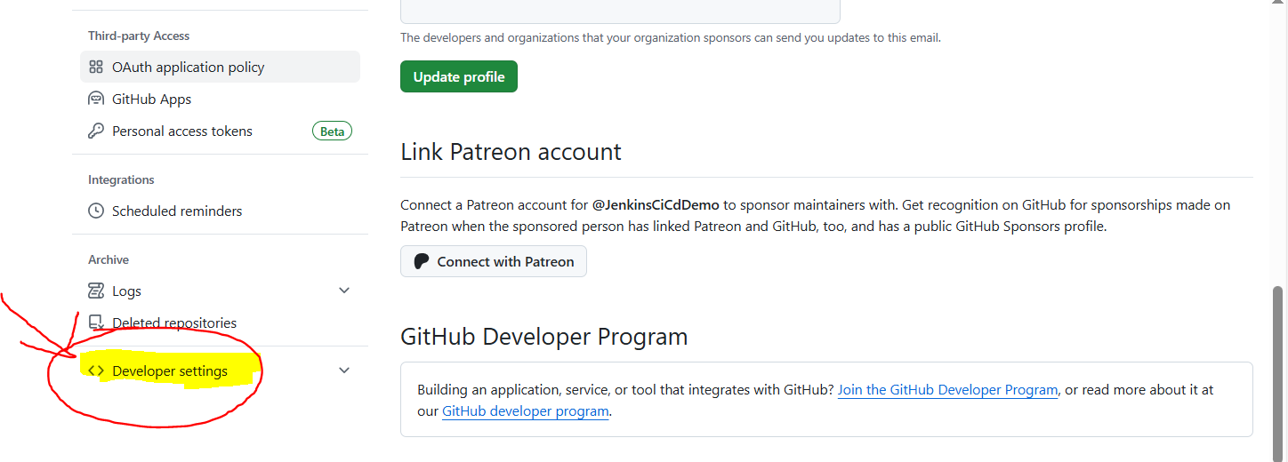
4. In the left sidebar, click **GitHub Apps**.  
   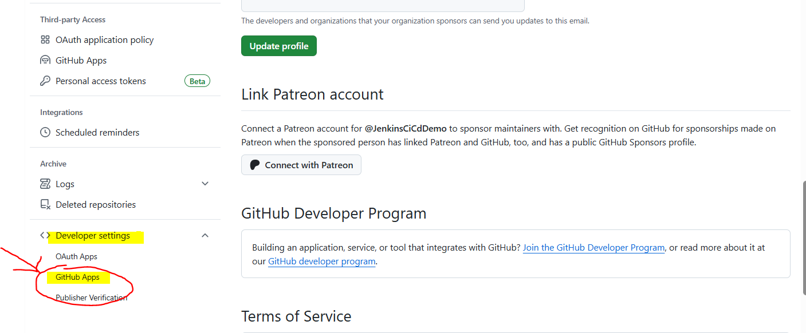
5. Click **New GitHub App**.  
   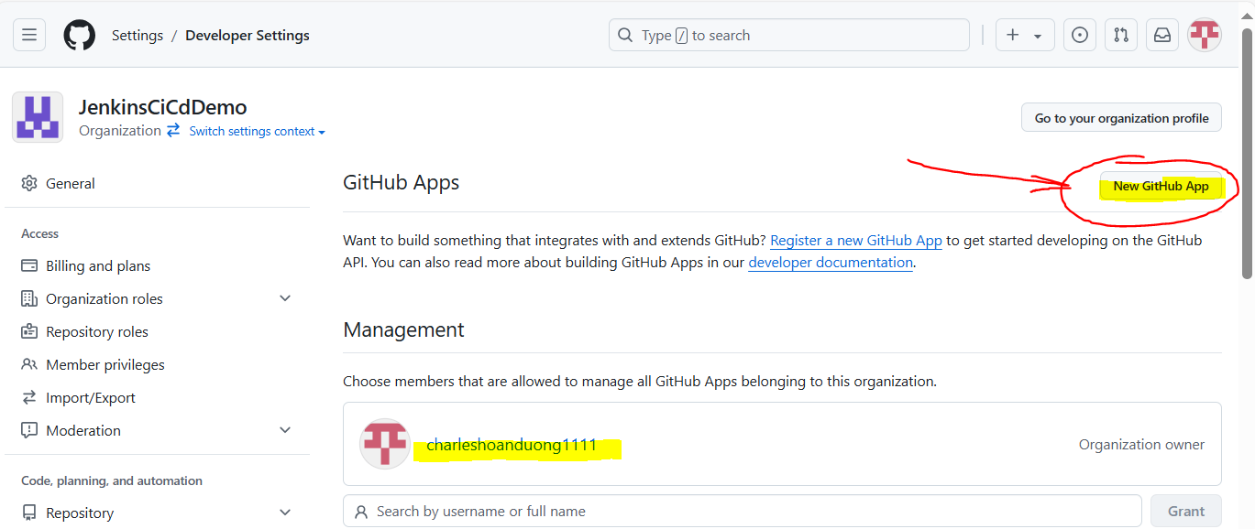
6. Under "GitHub App name", enter a name for your app. For example, USERNAME-quickstart-app where USERNAME is your GitHub username.
7. Under "Homepage URL", enter https://github.com/github/github-app-js-sample#readme.  
   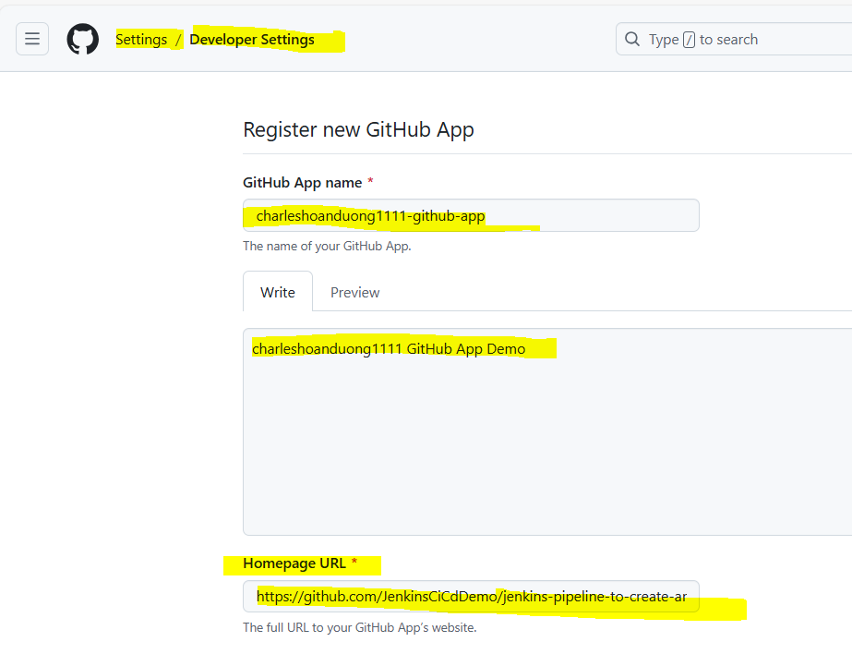  
   https://github.com/JenkinsCiCdDemo/jenkins-pipeline-to-create-angular-docker-image-and-push-to-docker-hub-demo#readme
8. Skip the "Identifying and authorizing users" and "Post installation" sections for this quickstart. For more information about these settings, see "[Registering a GitHub App](https://docs.github.com/en/apps/creating-github-apps/creating-github-apps/creating-a-github-app)."
9. Make sure that **Active** is selected under "Webhooks."
10. Under "Webhook URL", enter your webhook proxy URL from earlier. For more information, see "[Step 2: Get a webhook proxy URL](https://docs.github.com/en/apps/creating-github-apps/writing-code-for-a-github-app/quickstart#step-2-get-a-webhook-proxy-url)."  
    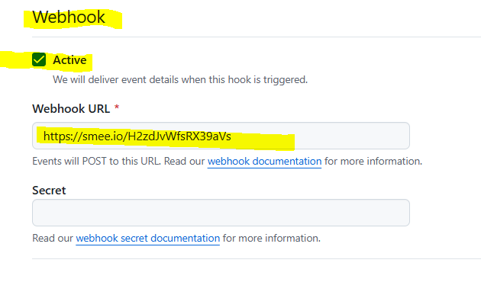
11. Under "Webhook secret", enter a random string. You will use this string later.
12. Under "Repository permissions", next to "Pull requests," select **Read & write**.  
    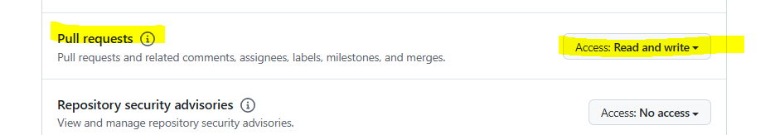
13. Under "Subscribe to events", select **Pull request**.  
    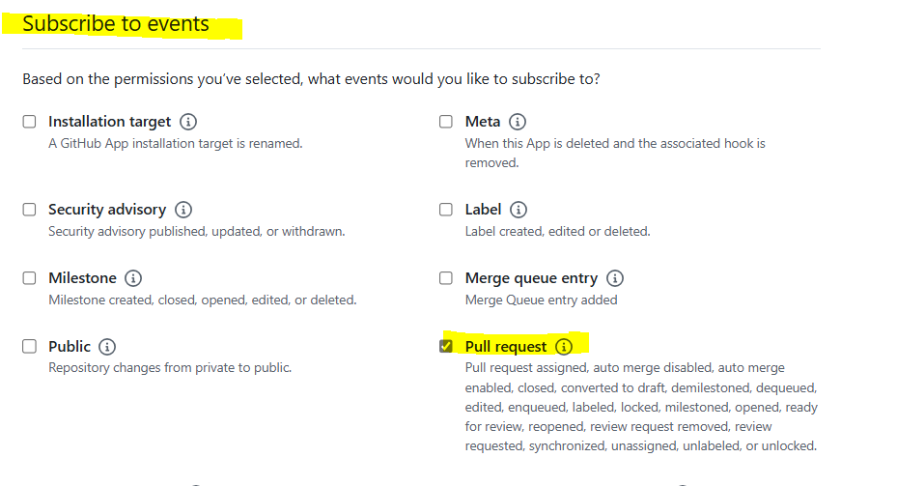
14. Under "Where can this GitHub App be installed?", select **Only on this account**.
15. Click **Create GitHub App**.  
    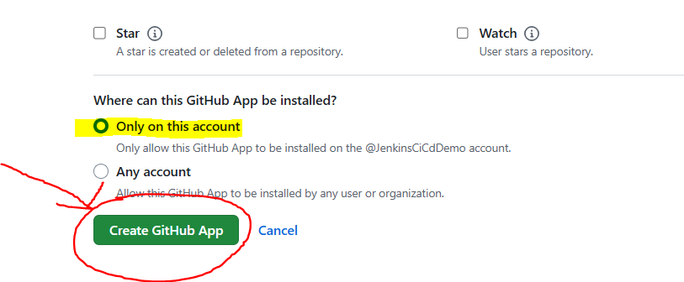

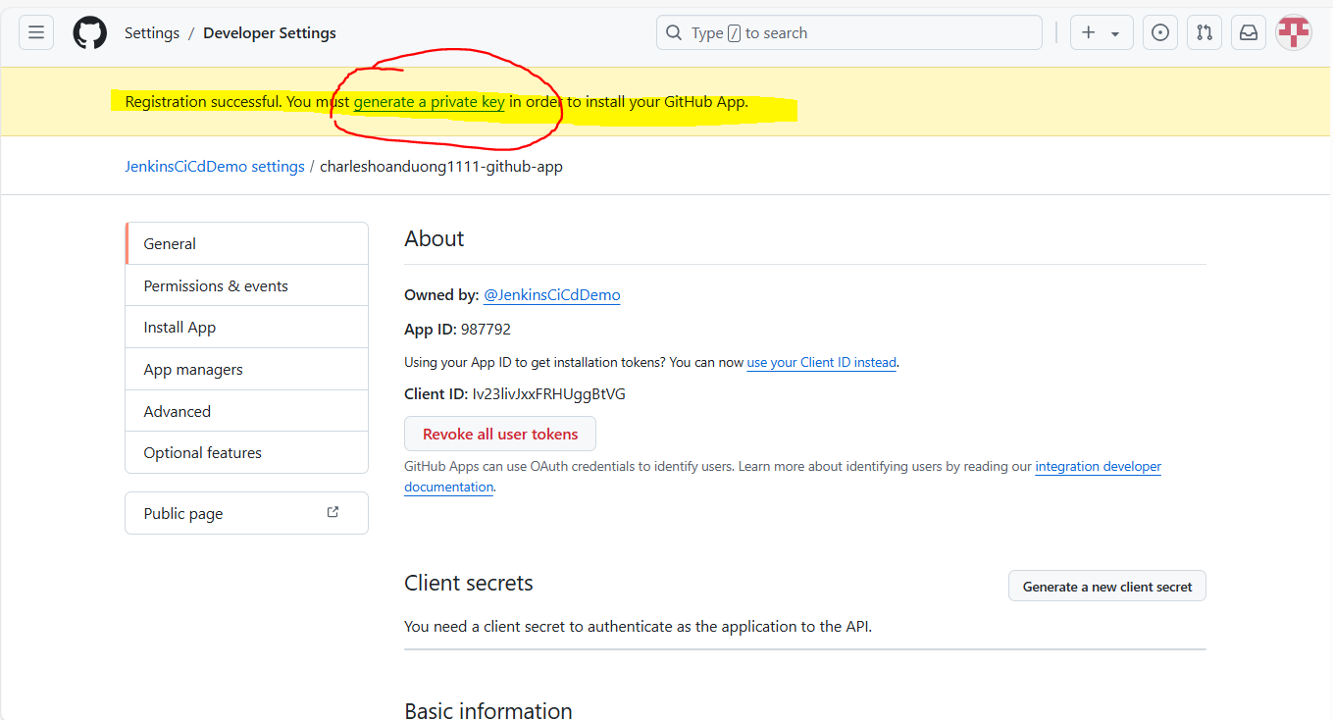

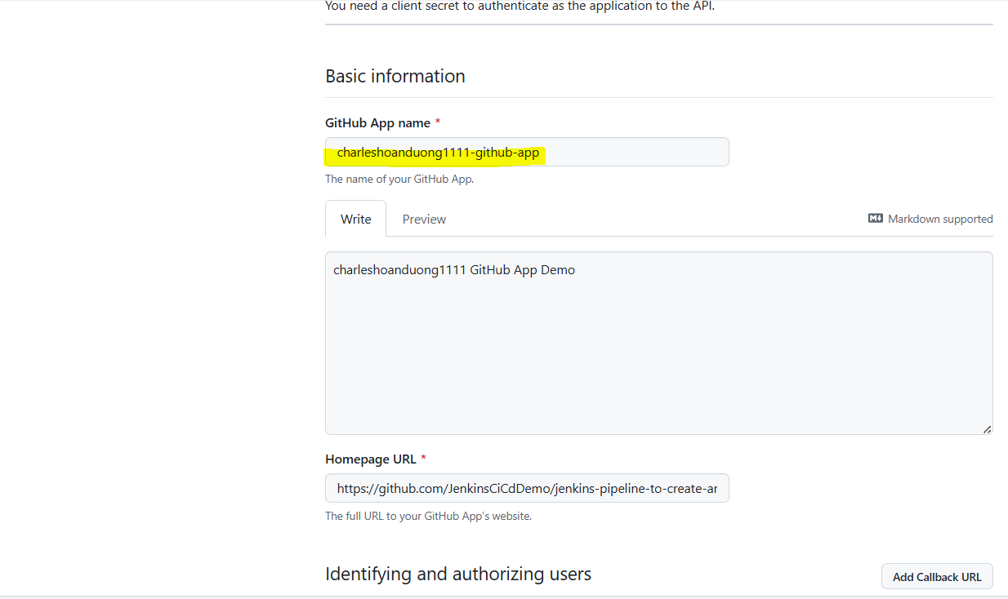

[**Step 4: Store identifying information and credentials**](https://docs.github.com/en/apps/creating-github-apps/writing-code-for-a-github-app/quickstart#step-4-store-identifying-information-and-credentials)

In this quickstart, you will store your app's credentials and identifying information as environment variables in a .env file. When you deploy your app, you will want to change how you store the credentials. For more information, see "[Deploy your app](https://docs.github.com/en/apps/creating-github-apps/writing-code-for-a-github-app/quickstart#deploy-your-app)."

Make sure that you are on a secure machine before performing these steps since you will store your credentials locally.

[**Create a .env file**](https://docs.github.com/en/apps/creating-github-apps/writing-code-for-a-github-app/quickstart#create-a-env-file)

Your cloned repository includes .env in the .gitignore file. This will prevent you from accidentally committing your app's credentials. For more information about .gitignore files, see "[Ignoring files](https://docs.github.com/en/get-started/getting-started-with-git/ignoring-files)."

1. Navigate to the directory where your clone of [github/github-app-js-sample](https://github.com/github/github-app-js-sample) is stored.
2. Create a file called .env at the top level of this directory.
3. Add the following contents to your .env file. You will update the values in a later step.

Text

APP_ID="YOUR_APP_ID"

WEBHOOK_SECRET="YOUR_WEBHOOK_SECRET"

PRIVATE_KEY_PATH="YOUR_PRIVATE_KEY_PATH"

[**Navigate to your app settings**](https://docs.github.com/en/apps/creating-github-apps/writing-code-for-a-github-app/quickstart#navigate-to-your-app-settings)

If you navigated away from your app settings after creating your app, navigate to the settings page for your app:

1. In the upper-right corner of any page on GitHub, click your profile photo.
2. Navigate to your account settings.
   * For an app owned by a personal account, click **Settings**.
   * For an app owned by an organization:
     1. Click **Your organizations**.
     2. To the right of the organization, click **Settings**.
3. In the left sidebar, click **Developer settings**.
4. In the left sidebar, click **GitHub Apps**.
5. Next to your app's name, click **Edit**.

[**Get your app credentials and identifying information**](https://docs.github.com/en/apps/creating-github-apps/writing-code-for-a-github-app/quickstart#get-your-app-credentials-and-identifying-information)

1. On your app's settings page, next to "App ID", find the app ID for your app.
2. In your .env file, replace YOUR_APP_ID with the app ID of your app.
3. On your app's settings page, under "Private keys", click **Generate a private key**. You will see a private key in PEM format downloaded to your computer. For more information, see "[Managing private keys for GitHub Apps](https://docs.github.com/en/apps/creating-github-apps/authenticating-with-a-github-app/managing-private-keys-for-github-apps)."
4. If you are using a codespace, move the downloaded PEM file into your codespace so that your codespace can access the file.
5. In your .env file, replace YOUR_PRIVATE_KEY_PATH with the full path to your private key, including the .pem extension.
6. In your .env file, replace YOUR_WEBHOOK_SECRET with the webhook secret for your app. If you have forgotten your webhook secret, under "Webhook secret (optional)", click **Change secret**. Enter a new secret, then click **Save changes**.

[**Step 5: Install your app**](https://docs.github.com/en/apps/creating-github-apps/writing-code-for-a-github-app/quickstart#step-5-install-your-app)

In order for your app to leave a comment on pull requests in a repository, it must be installed on the account that owns the repository and granted access to that repository. Since your app is private, it can only be installed on the account that owns the app.

1. In the account that owns the app you created, create a new repository to install the app on. For more information, see "[Creating a new repository](https://docs.github.com/en/repositories/creating-and-managing-repositories/creating-a-new-repository)."
2. If you navigated away from your app settings after creating your app, navigate to the settings page for your app. For more information, see "[Navigate to your app settings](https://docs.github.com/en/apps/creating-github-apps/writing-code-for-a-github-app/quickstart#navigate-to-your-app-settings)."
3. Click **Public page**.
4. Click **Install**.
5. Select **Only select repositories**.
6. Select the **Select repositories** dropdown menu and click the repository that you chose at the start of this section.
7. Click **Install**.

[**Step 6: Start your server**](https://docs.github.com/en/apps/creating-github-apps/writing-code-for-a-github-app/quickstart#step-6-start-your-server)

For testing, you will use your computer or codespace as a server. Your app will only be active when your server is running.

1. In a terminal window, navigate to the directory where your clone of [github/github-app-js-sample](https://github.com/github/github-app-js-sample) is stored.
2. To receive forwarded webhooks from Smee.io, run npx smee -u WEBHOOK_PROXY_URL -t http://localhost:3000/api/webhook. Replace WEBHOOK_PROXY_URL with your webhook proxy URL. If you forgot your URL, you can find it in the "webhook URL" field on your app's settings page.

You should see output that looks like this, where WEBHOOK_PROXY_URL is your webhook proxy URL:

Forwarding WEBHOOK_PROXY_URL to http://localhost:3000/api/webhook

Connected WEBHOOK_PROXY_URL

1. In a second terminal window, navigate to the directory where your clone of [github/github-app-js-sample](https://github.com/github/github-app-js-sample) is stored.
2. Run npm run server. Your terminal should say, Server is listening for events at: http://localhost:3000/api/webhook.

[**Step 7: Test your app**](https://docs.github.com/en/apps/creating-github-apps/writing-code-for-a-github-app/quickstart#step-7-test-your-app)

Now that your server is running and receiving forwarded webhooks events, test your app by opening a pull request.

1. Open a pull request on the repository you created in [Step 5: Install your app](https://docs.github.com/en/apps/creating-github-apps/writing-code-for-a-github-app/quickstart#step-5-install-your-app). For more information, see "[Creating a pull request](https://docs.github.com/en/pull-requests/collaborating-with-pull-requests/proposing-changes-to-your-work-with-pull-requests/creating-a-pull-request)."
2. Navigate to your webhook proxy URL on smee.io. You should see a pull_request event. This indicates that GitHub successfully sent a pull request event when you created a pull request.
3. In the terminal where you ran npm run server, you should see something like "Received a pull request event for #1" where the integer after the # is the number of the pull request that you opened.
4. In the timeline of your pull request, you should see a comment from your app. The comment uses the contents of the message.md file in your cloned repository.
5. In both terminal windows, enter Ctrl+C to stop your server and stop listening for forwarded webhooks.